**Integrated Science – Semester one test**

**Worth 4% Name: ______________________**

**Multiple choice** (3 marks)

1. Jason has a problem; his scalp is infested with lice. Which of the following statements accurately describes Jason’s relationship with the lice?

a) Jason is a consumer

b) Jason is a producer

c) Jason is a parasite

d) Jason is a host

1. The red-billed oxpecker has been described as a bird that helps giraffes by eating ticks and other harmful insects from their coats. But recent studies have shown that oxpeckers actually hurt giraffes by eating only fattened ticks that have already sucked blood, and by keeping wounds open by feeding on the blood themselves. So, in regards to the relationship between the oxpecker and giraffe:

a) They were thought to be mutualistic, but are actually parasitic

b) They were thought to be mutualistic, but actually commmensalistic

c) They were thought to be commensalistic, but actually parasitic

d) They were thought to be commensalistic, but are actually mutualistic

1. Certain animals that humans keep as pets, such as dogs, have lost the ability to survive in their natural ecosystems, yet there are more dogs living today than wolves which have maintained their ability to hunt for food and survive in the wild. What would best describe how this happened?

a) Dogs are naturally superior to wolves

c) Dogs have benefited through their mutualistic relationship with humans

d) Dogs have learned to organize into colonies, while wolves have not

**Short answer questions**

**Question 4**

Yellowstone National Park in the United States of America radically changed after humans exterminated the gray wolf from Yellowstone in the mid-1920s. Elk herds greatly increased in number over the next 70 years, overgrazing vast amounts of land and trees. Fewer trees sent the songbird population into decline. Beavers lost their food source and the wood to build their homes and dams. The lack of those dams caused streams to erode, making them deeper and not as wide and further degrading the conditions trees need to grow.

After wolves were reintroduced and added into the park, the top predators have helped parts of the ecosystem bounce back.

1. Write a hypothesis that predicts the impact of re-introducing the wolves into the park (2 marks)

|  |
| --- |
|  |
|  |
|  |
|  |

1. Identify the independent and dependent variables in this experiment (2 marks)

|  |
| --- |
|  |
|  |
|  |
|  |

Below is a table showing the population numbers of wolves and elk in Yellowstone over 20 years

|  |  |  |
| --- | --- | --- |
| Year | Number of wolves | Number of elk |
| 1996 | 19 | 13000 |
| 1997 | 30 | 12000 |
| 1998 | 40 | 12000 |
| 1999 | 38 | 14000 |
| 2000 | 65 | 13000 |
| 2001 | 70 | 12000 |
| 2002 | 80 | 10000 |
| 2003 | 100 | 9000 |
| 2004 | 85 | 9500 |
| 2005 | 95 | 7000 |
| 2006 | 97 | 6000 |

1. Draw a graph that shows the population of elk over the ten-year span (4 marks)



1. Explain whether your hypothesis was correct (2 marks)

|  |
| --- |
|  |
|  |
|  |
|  |

1. Some scientists in Britain are also considering re-introducing wolves into the ecosystems there. Using the food chains below, explain whether you think this is a good idea (3 marks)

|  |
| --- |
|  |
|  |
|  |
|  |
|  |
|  |
|  |
|  |

Before wolf hunting After wolf hunting

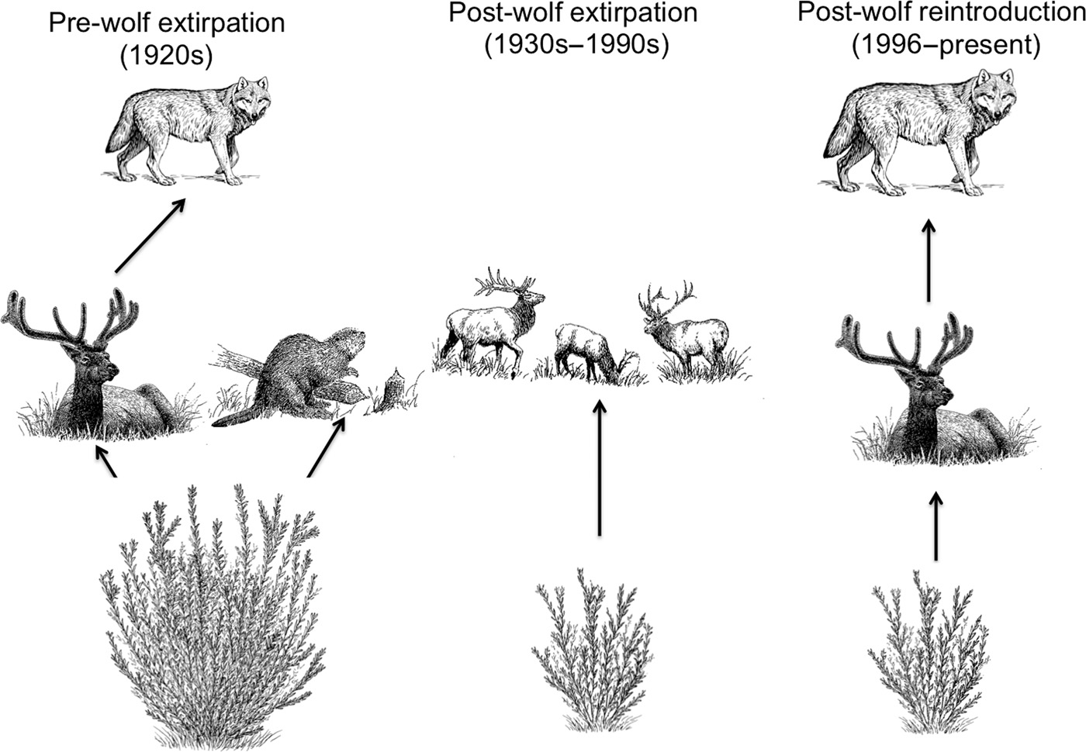

**Question 5**

Carp are a type of fish that has been introduced to Australia and have had a huge negative impact on ecosystems. They are highly aggressive to other fish and have a very varied and broad diet – they eat other fish as well as prawns, insects and plants. In northern Australia their only predator is the bull shark.

1. Based on the information above, complete this food web to include the carp (2 marks)

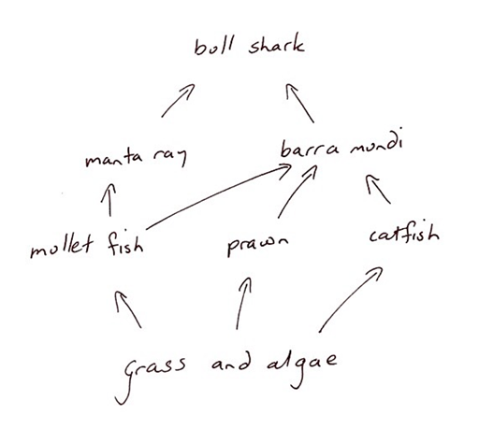

1. Use the food web below to draw a food chain that has four levels (2 marks)
2. Using your food web, predict two effects that the introduction of the carp might have had on the other organisms (2 marks)

|  |
| --- |
|  |
|  |
|  |
|  |

1. Name the type of organism that: (2 marks)
   1. Makes its own food

|  |
| --- |
|  |

* 1. Breaks down decaying matter and detritus

|  |
| --- |
|  |

1. From the food web, give an example of the following (5 marks)
   1. Primary consumer

|  |
| --- |
|  |

* 1. Tertiary consumer

|  |
| --- |
|  |

* 1. Producer

|  |
| --- |
|  |

* 1. Predation

|  |
| --- |
|  |

* 1. Competition

|  |
| --- |
|  |

**Question 6**

A population of grasshoppers in an ecosystem has two colours, green and brown. Typically, the ecosystem receives adequate water to maintain healthy, green grass. Assume a bird that eats grasshoppers moves into the prairie.

1. Describe natural selection (2 marks)

|  |
| --- |
|  |
|  |
|  |
|  |

1. Explain how the arrival of the bird will affect the natural selection of the grasshoppers

(2 marks)

|  |
| --- |
|  |
|  |
|  |
|  |

1. How did the differences in grasshopper colour help the survival of the species? (2 marks)

|  |
| --- |
|  |
|  |
|  |
|  |

**Question 7**

1. Describe the following terms (3 marks)
   1. Symbiosis

|  |
| --- |
|  |
|  |
|  |

* 1. Parasitism

|  |
| --- |
|  |
|  |
|  |

* 1. Reliability

|  |
| --- |
|  |
|  |
|  |

1. Explain why decomposers are important in food chains (2 marks)

|  |
| --- |
|  |
|  |
|  |
|  |
|  |
|  |

/40